To Add a Glossary to Your Course
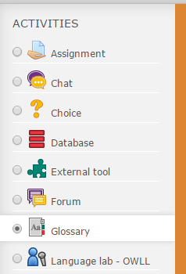
1. Click the Turn editing on button.
2. Locate the section in your course to add the Glossary. Click Add an activity or resource, choose Glossary and click Add.

Important General Settings
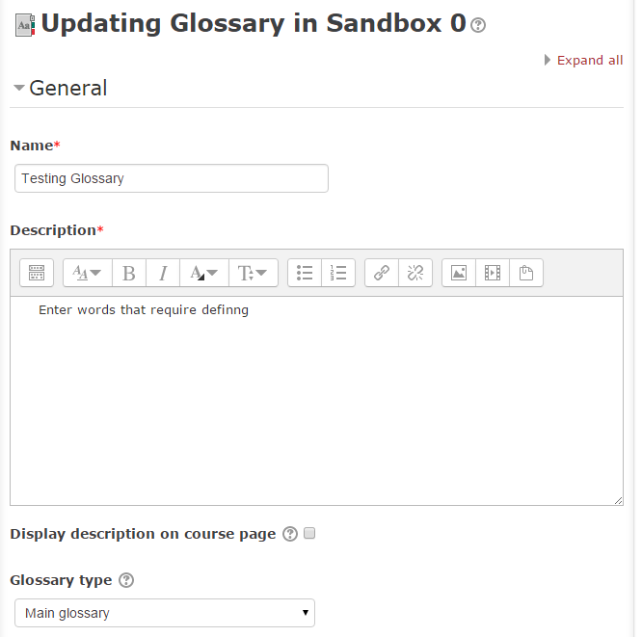
Name and Description: When naming, consider if this glossary fits within a series or a unit. Would it be helpful to have the unit number etc. in the name?
Display description on course page: If this box is checked, the description will appear on the course page just below the name of the database.
Glossary type: Here you can decide whether the glossary will be the main glossary or a secondary glossary. The main glossary is for the whole course. The glossary system allows you to export entries from any secondary glossary to the main one of the course. You can have only one main glossary per course.

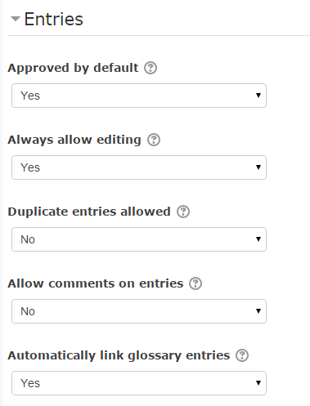
Defining Entries
Approved by default: This allows the teacher to define what happens to new entries added by students. They can be made available automatically to everyone; otherwise the teacher will have to approve each one.
Always allow editing
This setting specifies whether entries can be edited at any time or only during the editing window (30 minutes after posting).
Duplicated entries allowed: This allows the entry of more than one definition for a given word.
Allow comments on entries: Students and teachers can leave comments on glossary definitions. The comments are available through a link at the bottom of the definition.
Automatically link glossary entries: This allows entries in a glossary to be automatically linked whenever the concept word or phrases appear in individual activities or the entire course itself. See below for more settings.

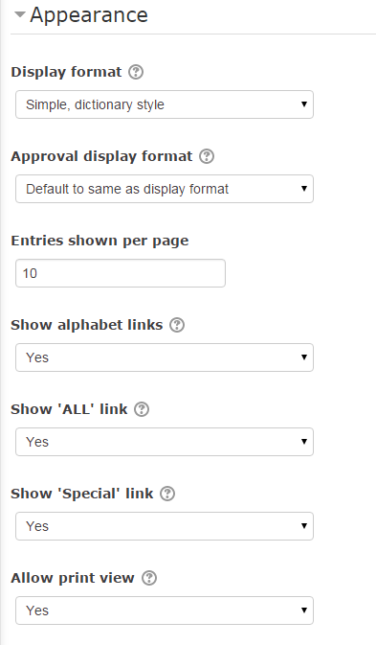
Appearance Settings
Display format: This specifies the way each entry will be shown within the glossary. The default formats are as follows:
Simple, dictionary style – Looks like a conventional dictionary with separate entries. No authors are displayed, and attachments are shown as links.
Continuous without author – Similar to the simple style. Shows the entries one after another without any kind of separation other than the editing icons, if your theme supports them.
Full with author – A forum-like display format showing the author’s data. Attachments are shown as links.
Full without author – A forum-like display format that does not show author's data. Attachments are shown as links.
Encyclopedia – Similar to “Full with author” except that attached images are shown inline.
Entry list – Lists the concepts as links.
FAQ – Useful for displaying lists of frequently asked questions. Automatically appends the words QUESTION and ANSWER in the concept and definition, respectively.

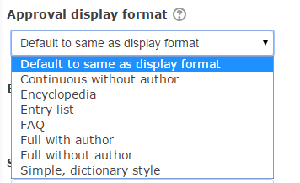

Approval display format:
When approving glossary items, you may wish to use a different display format.

Entries shown per page: This sets the number of words and definitions that students will see when they view the glossary list. If you have a large number of automatically-linked entries, you should set this number lower to prevent long loading times.
Show alphabet: If enabled, participants can browse the glossary by letters of the alphabet.
Show “All” link: If enabled, participants can browse all entries at once.
Show special link: If enabled, participants can browse the glossary by special characters, such as @ and #.
Allow print view: This provides students with a link to a printer-friendly version. (Teachers are always provided with a printer-friendly version link.)


Grade Settings
Grade: Choose the category in which this database will appear if ratings are enabled. (This setting is collapsed by default.)
Ratings Settings
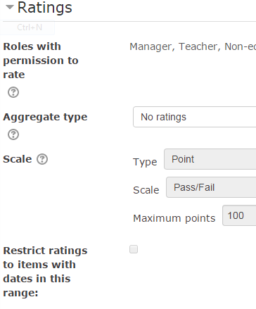
Roles with permissions to rate: Database entries can be rated using a scale. Any ratings given are recorded in the Gradebook.
Aggregate type: The aggregate type defines how ratings are combined to form the final grade in the Gradebook.
- Average of ratings – The mean of all ratings.
- Count of ratings – The number of rated items becomes the final grade. Note that the total cannot exceed the maximum grade for the activity.
- Maximum – The highest rating becomes the final grade.
- Minimum – The smallest rating becomes the final grade.
- Sum – All ratings are added together. Note that the total cannot exceed the maximum grade for the activity.
Note: If "No ratings" is selected, then the activity will not appear in the Gradebook.
Scale: Database entries can be rated based on a numeric mark, pass/fail, or separate and connected ways of knowing.
Restrict ratings to items with dates in this range: If this feature is enabled, only database entries within the date ranges listed will be counted when calculating marks (using the aggregation type suggested previously).

Common Module Settings:
Visible: Show or hide the database from student view.

Adding Items and Searching the Glossary
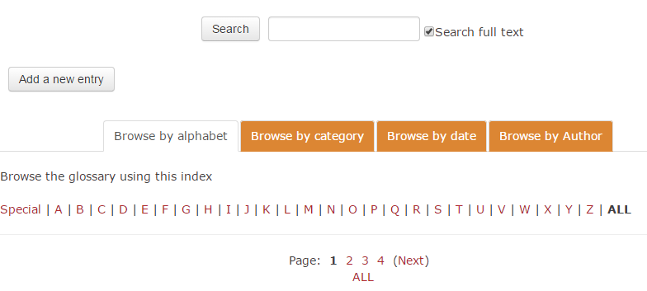

Once the glossary has been created, click on the Add a new entry button to make a new glossary entry.
Use the Browse tabs to search through existing glossary entries.

Linking Glossary Entries:

Automatically link glossary entries: This allows individual entries in a glossary to be automatically linked whenever the concept word or phrase appears in individual activities or the entire course itself. For auto-linking glossary entries to work, three settings need to be considered:

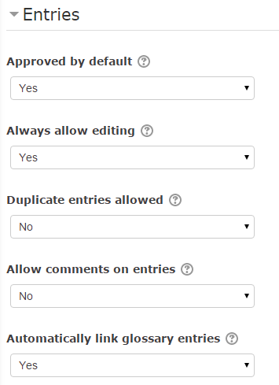
1. In the Glossary settings: The “Automatically link glossary entries” option needs to be set to “Yes”.

2. In Administration: The “Glossary auto-linking” filter needs to be turned on, either on an activity level or on a course-wide level.

To change the Glossary auto-linking filter so that glossary entries are linked within the entire course, locate the ADMINISTRATION block on your main course page.
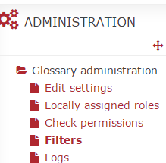
- Under “Course Administration”, click the “Filters” link. In the “Glossary auto-linking” drop-down box, select the “On” option.
- To set auto-linking in an individual activity or resource, locate the “Filters” link in the ADMINISTRATION block for the activity/resource.
- Note: If you want to have auto-linking to occur for some activities and resources, but not for the entire course, leave the course-wide Glossary auto-linking filter off and change the filter settings in the activity/resource itself.
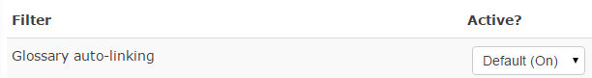
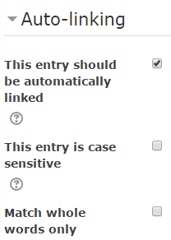

3. For each individual entry in the glossary, the “This entry should be automatically linked” option needs to be selected.

Note: If you do not want particular text to be linked (for example, in a forum posting), then you should add <nolink> and </nolink> tags around the text (using the HTML button in the text editor box).
Once the glossary has been created, click on the Add a new entry button to make a new glossary entry.
Use the Browse tabs to search through existing glossary entries.

